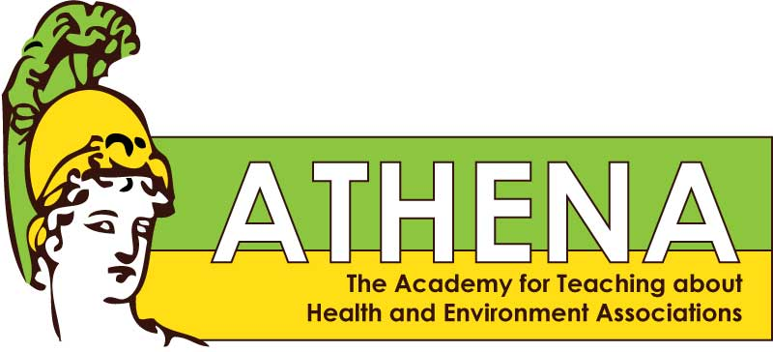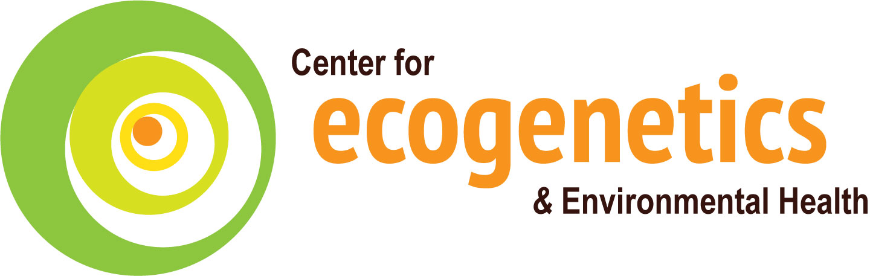**

The ATHENA Project launched in 2010 with a teacher workshop introducing 23 Science, Health and Family Consumer Sciences teachers to environmental health sciences (EHS). EHS researchers from the UW Center for Ecogenetics and Environmental Health (CEEH) provided EHS content. During the school year, these ATHENA teachers from across Washington state presented EHS lessons in their classrooms.

One enthusiastic ATHENA teacher recruited her fellow Health teachers to participate in ATHENA; the 2012-13 ATHENA cohort was comprised of all eight Bellevue School District (BSD) health teachers. Over the next school year, the BSD teachers developed EHS lessons. The teachers then approached CEEH for help to create a district-wide EHS curriculum.

In response, two summer ATHENA Workshops were held in 2014. At the first, the BSD teachers engaged with Center researchers for content to create an EHS curriculum for Health classes. At the second, a new cohort of Health teachers from central WA learned about EHS from Center researchers and received EHS lessons from the BSD Health teachers. Seven EHS lessons were created and shared. 2014 ATHENA teachers piloted the EHS lessons in their classrooms, and ATHENA staff used teacher feedback to revise, update, and promote the ATHENA EHS curriculum.

In August 2016, 20 Health and CTE teachers from 15 school districts across Washington attended the 2016 ATHENA teacher workshop. The theme was *Consumerism, Choices & Health.* Six UW researchers presented on topics paired with ATHENA classroom lessons. Teachers also toured a research lab.

The ATHENA EHS lessons for Health classes are available for FREE download and use at: <http://deohs.washington.edu/edge/educator-resources>

1,108 3,300

**What was the most valuable part of the workshop?**

### Teacher Feedback

Lessons Piloted:

Students received one or more EHS lessons:

High Schools Reached:

Teachers Participated:

14 20

**The ATHENA Story**

### ATHENA Outcomes 2014 2016

7 16

7 7

* Experts coming in
* Opportunity to ask questions & collaborate
* Sharing the lessons we wrote

**What did you learn?**

* Information on GMOs, nutrition, toxicity
* A way to discuss ethics
* Confidence in talking about EHS
* Ways to include EHS in my classes

**What did students find most useful?**

* Seeing the link between personal choice & health
* Seeing the difference using sunscreen makes
* Making other connections to their own lives
* Looking at multiple perspectives without being biased
* Understanding the science behind GMOs
* Being able to talk about electronic cigarettes

The Academy for Teaching about Health and Environment Associations