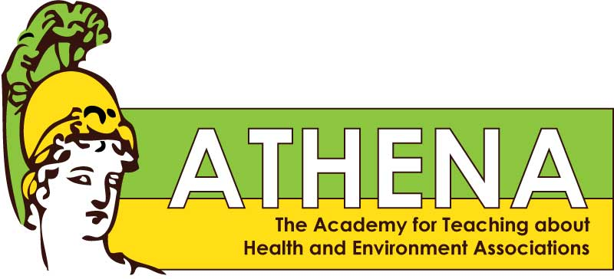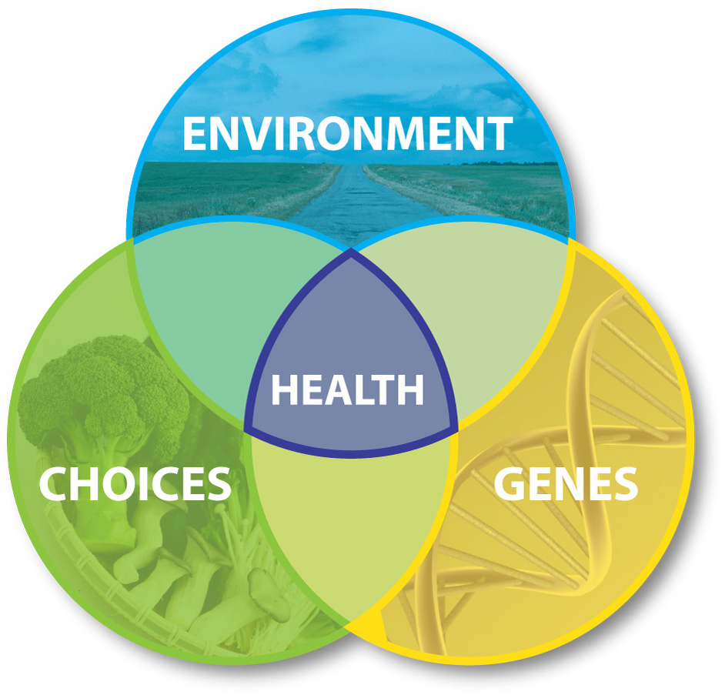**

Environmental health is a branch of public health that addresses every aspect of the natural and built environment that may affect human health and wellbeing.

The ATHENA teacher-training project is a program of the University of Washington Center for Ecogenetics and Environmental Health. Since 2010, the ATHENA project has hosted teacher trainings for high school teachers to learn about health risks posed by environmental hazards. ATHENA gives teachers skills and resources to help students understand environmental hazards and to empower them to make behavior changes to protect themselves and their communities. Since 2010, 56 teachers from Washington State have participated in ATHENA teacher workshops.

Learn more about ATHENA at: [**http://deohs.washington.edu/edge/athena**](http://deohs.washington.edu/edge/athena)

# What is ATHENA?

# FREE Environmental Health Lessons for your Classroom

#### Apply to attend an ATHENA workshop

* OSPI-validated Continuing Education Credits available
* To apply to attend a workshop, contact Marilyn Hair at [marhair@uw.edu](mailto:marhair@uw.edu)

#### What is Environmental Health?

Download FREE teacher-created and tested Environmental Health Sciences lessons for use in high school health classes. Includes Lesson Plan, Supply List, Student Worksheet, and Factsheet or PowerPoint presentation.

Lessons include the following topics:

* **Electronic Cigarettes & Vaping**
* **Genetic Testing & Ethics: *Your Money or Your Life***
* **Genetically Modified Organisms: *GMO Salmon***
* **Introduction to Health: *Family Tree***
* **Sugars & Artificial Sweeteners**
* **Sunscreen & UV Radiation**

Lessons are available for download at: [**http://deohs.washington.edu/edge/educator-resources**](http://deohs.washington.edu/edge/educator-resources)

“ATHENA gave me ways to build relationships with students on topics relevant to them and their families.”

Testimonials from ATHENA teachers:

“I got scientific perspective on environmental health topics.”

“My students have a greater appreciation for the factors that contribute to health.”

**The Academy for Teaching about Health and Environment Associations**