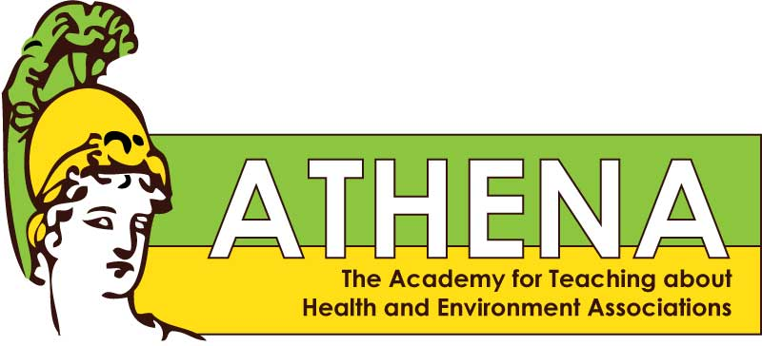

2016 Summer Workshop Training in Environmental Health
Consumerism, Choices and Health
Sponsored by the U of Washington EDGE Center: Exposures, Diseases, Genomics & Environment
August 2-3, 2016 4225 Roosevelt Way NE, Room 2228

Tuesday August 2

8:30 - 10:00 Welcome Dr. Terry Kavanagh
Introductions, and Pre-Survey
Activity: Environmental Health Venn Diagram Lindzee Alvarez and Tori Marcum Presentation: Intro to Environmental Health Marilyn Hair
Break

10:15 - Noon Ingestion
Presentation: Nutrition Q&A Dr. Michael Rosenfeld
Activities: Sugar & Artificial Sweeteners Lindzee & Tori
GMO Salmon Lindzee & Tori

Noon - 1:00 Lunch

1:00 - 2:30 Presentation: Vitamins and Supplements Dr. Libin Xu
Activity: Brainstorming a Lesson Plan
Break Walk or ride shuttle bus to Health Sciences building

2:45 - 4:00 Tour of Xu Lab

Weds August 3

8:30 - 10:00 Artifact activity Marilyn Hair
Absorption
Presentation: Cancer Dr. Rose James
Activity: UV Exposure & Sunscreen Lindzee & Tori
Break

10:15 - Noon Inhalation
Presentation: Our Lungs David Scoville
Presentation: Talking to Kids about Tobacco Bev Stewart
American Lung Association
Activity Electronic Cigarettes Lindzee & Tori

Noon - 1:00 Lunch

1:00 - 2:30 Presentation: Ethical Frameworks Dr. Kelly Edwards
Activity: Your Money Or Your Life Lindzee & Tori

2:30 - 3:00 Evaluations, STEM Clock Hours, Teacher Kits, Accountability
to teach, report back, & evaluate ATHENA materials

