**ATHENA Workshop for Health, Human Geography and CTE Teachers August 2-3, 2016**

**Information Sheet**

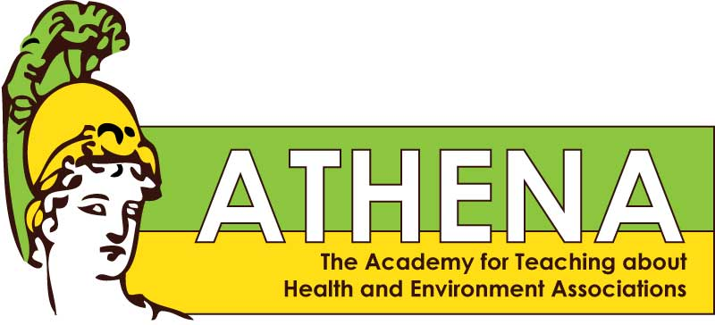

**Summer Workshop Training in Environmental Health**

**Theme: “Consumerism, Choices and Health”**

*Sponsored by the University of Washington*

*Interdisciplinary EDGE Center - Exposures, Diseases, Genomics and Environment*

**Training & Curriculum for Health, Human Geography and CTE Classes**

* This 2-day workshop will give you background and tools to teach students about important ways the environment affects human health
* Curriculum supports Secondary Health Grade Level Standard 3, “Student analyzes and evaluations the impact of real-life influences on Health” and 3.1, “Understands how family, culture, and environmental factors affect personal health”
* Presentations by UW faculty experts in the field of Environmental Health
* Lab Tour
* Hands-on: Try out lessons written and used in Health classrooms by ATHENA-trained Health Teachers about: What is Environmental Health? E-Cigarettes, UV, Cancer & Sunscreen, Sugars & Artificial Sweeteners, Genetically Modified Organisms
* You will be given two classroom kits, one for “UV Exposure & Sunscreen” and one for “Sugar & Artificial Sweeteners”
* $75 total honorarium
* Monday & Tuesday overnight accommodations for those who live at least 60 miles away, Tuesday overnight for those who live 20-60 miles away
* Box lunch on Tues & Weds
* Round-trip mileage, ride-sharing encouraged
* Access to experienced mentor-teachers and ATHENA staff
* You will be expected to:

(1) Teach at least 2 of the ATHENA EHS lessons with your students during 2016-17 (2) Provide feedback on your teaching to the ATHENA staff on a provided form

(3) Stay in touch with the ATHENA Project.



