ACCIDENT PREVENTION
PROGRAM

ADDENDUM TEMPLATE

for

Occupational Reproductive Health

CUSTOMIZE THIS TEMPLATE and ADD IT
TO YOUR Accident Prevention Program

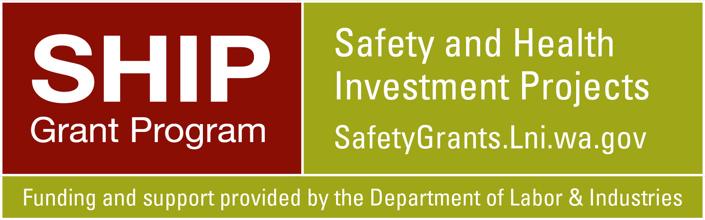

Funding and support for this project has been provided by the State of Washington, Department of Labor & Industries, Safety & Health Investment Projects (SHIP).
2/5/2022

TABLE OF CONTENTS

Subject | Page
Brief Introduction to Occupational Reproductive Health Hazards | 3-4
Sample Addendum to the Accident Prevention Program for Occupational Reproductive Health | 5-9
Appendix A: Occupational Reproductive Health Hazards Resources | 10
Appendix B: WA State Pregnancy Accommodation and Other Information | 11
Appendix C: Medical Consultation Services and Occupational Health and Safety Specialists | 12

Brief Introduction to Occupational Reproductive Health Hazards
(See Appendix A for Resources)

Purpose: To help prevent the following occupational reproductive health outcomes.

- Infertility in workers such as low sperm count, menstrual disorders, decreased sex drive, and germ cell changes.

- Adverse impacts on the health of workers’ offspring such as:
- Miscarriage, birth defects, low birth weight, and pre-term birth;
- Cognitive delays, disabilities and behavioral issues in children; and,
- Cancer in childhood and/or adulthood.

- The transfer of workplace chemicals to workers’ offspring in breastmilk and from tracking contaminants home on work clothing and footwear.

Why is this important? The average cost of the birth and care of a premature baby is around ten times higher than the cost of medical care for a healthy, full-term baby. Children with birth defects, brain damage, cancer, and other serious health problems may require expensive safety net services for years, decades, or throughout their lives.

Examples of Occupational Reproductive Health Hazards

Activities | Physical Agents | Infectious Agents and Diseases | Chemicals
- Heavy or repetitive lifting  - Excessive standing, walking, bending  - Shift work, long hours  - Stress | - Ionizing radiation  - Loud noise  - High heat  - Whole body vibration | - Covid-19 (SARS-CoV-2)  - Cytomegalovirus (CMV)  - Parvovirus  - Rubella  - Toxoplasmosis  - Many others | - Lead, cadmium, other metals  - Organic solvents: toluene, xylene, TCE  - Sterilants: formaldehyde, glutaraldehyde, ethylene oxide  - Hazardous drugs  - Welding fumes  - Pesticides and herbicides  - Asphalt fumes  - Many others

Common pregnancy-related symptoms and/or changes

- Early pregnancy
- Nausea and vomiting
- Fatigue
- Dehydration
- Late pregnancy
- Dehydration
- Back and joint pain
- Increased joint laxity
- Shifting center of gravity, balance issues
- Physical discomfort from enlarging uterus
- Varicose veins, hemorrhoids, heartburn

- Postpartum recovery. Giving birth can be traumatic on the body, and may require surgery and a recovery period.

Example job tasks and jobs that may harm the reproductive health of workers

- Tasks: Repeatedly lifting heavy items greater than 17 pounds; standing all day; operating a loud saw; driving a forklift; working with animals or humans; using leaded solder; degreasing with solvents; working with hazardous drugs

- Jobs: Warehouse workers; laborers; health aides; nurses; service workers; sawmill workers; veterinarians; lead battery workers; mechanics; industrial painters; carpenters; loggers; groundskeepers; hairdressers; mechanics; plumbers; road transportation workers; roofers

Laws about pregnant workers
- Important benefits flow from employment such as income, career development, health insurance, sick leave, and postpartum leave. It is important that employment is maintained for pregnant workers.

- Laws pertaining to pregnant workers
- Federal Pregnancy Discrimination Act: Treat pregnant workers and new parents the same as other workers. It is illegal to fire or discriminate against a worker due to pregnancy, child birth, or a related medical condition.
- Pregnancy and FMLA: Protect and hold jobs for workers who take medical or parental leave.
- WA Paid Family Medical Leave (FMLA): Paid family and medical leave for workers, including for new parents.
- WA Health Starts Act: Provide reasonable accommodations for pregnant and breastfeeding workers, if requested by the worker or the worker’s health care professional. This may include:
    - The need for brief water, food, rest, and bathroom breaks;
    - Changes in requirements to repetitively lift heavy objects or stand during the shift;
    - Changes to reduce exposures to chemicals or noise exceeding 85 dBA; or,
    - Break time and a place other than a bathroom to express breast milk.

Sample Addendum to the Accident Prevention Program for
Occupational Reproductive Health

(Text in italics is intended as guidance and may be deleted.)

(Employers: Evaluate and consider the specific work activities (i.e., exposures to chemicals, infectious and physical agents, and physical activities) at your workplace that are reproductive health hazards. Tailor this addendum to your workplace.)

(Addressing workplace reproductive health hazards will improve the wellbeing of pregnant workers, their children, and the health of Washington’s workforce.)

Purpose:

The purpose is to help prevent adverse occupational reproductive health events, such as infertility, miscarriage, preterm birth, birth defects, cancer, diseases, cognitive delays, and behavioral issues in the offspring of workers.

Identify reproductive health hazards in your workplace

(Assign someone to identify reproductive health hazards in your workplace.)

(Describe the methods your company will use to identify reproductive health hazards in your workplace. More than one method may be needed. Tools include a checklist that identifies chemicals, biological and physical agents, and work activities that are considered workplace reproductive health hazards; and careful review of the safety data sheets (SDSs) for the products used at your workplace.)
(Request current safety data sheets dated January 2016 or later. Look for SDSs that have the health hazard pictogram, and one or more of the below hazard statements for reproductive hazards.)

- (May cause genetic defects OR Germ Cell Mutagenicity (H340, H341))
- (May damage fertility or the unborn child OR Reproductive Toxicity (H360, H361 or H360/H361 followed by a letter, such as H361d))
- (May cause harm to breastfed children OR effects via lactation (H362))

(See Appendix A for a checklist, employer guide, and other information about reproductive health hazard identification.)

Workers covered under this program

(Anyone potentially exposed to reproductive hazards in your workplace as identified through the process your company uses to identify reproductive hazards.)

Workers who have the following job tasks at our worksite are considered to be exposed to occupational reproductive hazards.
Job task: (For example, repeatedly lifting heavy items greater than 17 pounds; standing all day; operating a loud saw, driving a forklift; working with animals or humans; using leaded solder, degreasing with solvents, working with hazardous drugs. For examples of jobs with reproductive hazards, see page 4 of this document and the resources in Appendix A).

Job or job task:

(Identify who is responsible for listing the jobs and/or job tasks that pose a reproductive health risk at your workplace, and who is responsible for maintaining this list.)

Control exposures to occupational reproductive health hazards by using methods to eliminate or reduce exposures, or accommodate workers as required

(Identify who is responsible for developing strategies to control the hazards identified at your workplace. Describe the steps to reduce risks, and the procedures employees must follow to decrease their exposures and/or modify their work activities. Define a timeframe to periodically review and update the strategies as needed to ensure continued effectiveness.)

(One helpful approach is completion of a job hazard analysis (JHA) for each reproductive health hazard. See Appendix A for a JHA template and other resources to identify and control reproductive health hazards.)

(In developing methods to protect employees, consider the below questions.
- Is there a less hazardous way to do the job?
- Can the hazard be eliminated, substituted, or reduced (e.g., use ChemHat or other approach to identify safer substitutes)?
- Can the physical conditions that created the hazard be changed?
- Can engineering controls be used?
  - Local exhaust ventilation to reduce chemical exposures?
  - Mechanical lift devices or other devices to address repetitive, heavy lifting?
  - A chair to reduce time standing?
- Can administrative controls be used?
- Can personal protective equipment be used?)

(Consider listing the JHAs at your company that address reproductive health hazards.)

JHA: (For example: Lead-soldering tasks. Only lead-free solder will be purchased and used at (your company).)

(Ensure identified hazards are addressed by the controls and/or other methods identified by your company. Ensure the procedures to reduce risks are described in sufficient detail to protect workers).

Training

(Identify who is responsible for training workers on the occupational reproductive health hazards in your workplace. Ensure the procedures to control reproductive health hazards are explained to exposed workers. Decide on the frequency of retraining workers and updating the training content.)

Employee awareness

- Introductory information about reproductive health medical problems. Family formation problems (i.e., infertility, miscarriage, preterm birth) are common in the general public. Only a small amount of research has been conducted on the health effects of exposures to reproductive health hazards in the workplace.

- The jobs and/or job tasks at your worksite that may cause reproductive health problems.
Include chemicals, physical and biological agents, and workplace activities.
  - Provide refresher hazard communication training with a focus on reproductive health hazards. Ensure workers know how to obtain SDSs, and how to identify those products that are reproductive health hazards.
  - Ensure workers understand occupational permissible exposure limits (PELs) do not protect the developing child.
  - Educate workers that some workplace chemicals can harm children at home. Some chemicals pass into human milk (i.e., lead, cadmium), and some are tracked home on a worker’s clothing or footwear (i.e., lead, asbestos).

- The steps your company has taken to reduce or prevent exposure to reproductive health hazards using control procedures, work practices, personal protective equipment, accommodation, and other methods. Workers and supervisors share responsibility for safety in the workplace.

- How full time noise exposure exceeding 85 dBA may cause blood pressure disorders and gestational diabetes in pregnant workers. Excessive loud noise (working near heavy machinery, sirens, jack hammers, chain saws, airplane engines) may cause hearing loss in the developing child. Hearing protection will not protect the hearing anatomy of the developing child.,

- How high-temperature environments may cause infertility in male workers (i.e., bakers). Pregnant workers are more susceptible to heat-related illnesses and death. High-temperature environments may cause birth defects, preterm or still birth, and low birth weight in the children of pregnant workers.

- How full-time exposures to whole body vibration may cause preterm birth in pregnant forklift and heavy truck operators, and others with high, full-time exposure.
- The ability to have accommodations to prevent adverse health and pregnancy outcomes. Accommodations may be requested by a worker or a clinician.
  - Pregnant workers may need:
    - Longer and more frequent water, food, rest and bathroom breaks;
    - To reduce the frequency of standing and/or lifting tasks;
    - To work the day shift;
    - To reduce exposures to chemicals, noise or vibration; and/or,
    - Other pregnancy accommodations as allowed under the Washington Healthy Starts Act (See Appendix B for additional information).
  - An employer may not request medical certification on the need for a pregnant worker’s medical need for accommodations. An employee’s private health information is confidential.
  - A clinician may request accommodation for reasonable break times to express milk, and provision of a private location (other than a bathroom), is required if feasible. (See Appendix B for additional information)
    - Expressing breast milk on a schedule maintains breastfeeding and prevents breast infections.
    - Human milk is the healthiest option of nutrition for newborns and infants.
  - A clinician may request accommodation for a worker with other reproductive health conditions, such as infertility or history of miscarriage, under other anti-discrimination laws.

- The availability of medical experts to address workers’ concerns about workplace reproductive health hazards and pregnancy, breastfeeding and infertility. (See Appendix C for resources)

- The laws that protect the rights of pregnant and breastfeeding workers. Undocumented workers are also protected under the WA Healthy Starts Act and other state and federal anti-discrimination laws.

Supervisor awareness (in addition to what is detailed for employees above)

  - Workers will generally keep family formation plans private, so training is especially important when workers are exposed to chemicals, physical agents, and infectious agents that may harm fertility or cause first trimester harm to the developing child.

  - Important benefits that flow from employment include income, career development, health insurance, sick leave, and postpartum leave. It is important that employment is maintained for pregnant workers.
    - Around 75% of women entering the workforce will be pregnant and employed at some point in their lives.
    - Around two-thirds of working women are the sole, primary, or co-breadwinner for the family.
    - Around 53% of pregnant workers report a need to change their job duties, and 37% of these pregnant workers never request changes.

  - Occupational health and safety experts are available to assist employers with the identification and control of workplace reproductive health hazards. (See Appendix C for resources)

  - Under Washington state law, an employer may not refuse to accommodate a pregnant worker, unless doing so would impose an “undue hardship.” In Washington state, undue hardship is defined as “an action requiring significant difficulty or expense.” (See Appendix B for resources)

  - At some worksites, it may be prudent to plan for accommodation requests. Accommodation may be the only option to protect pregnant workers from certain occupational reproductive health hazards, such as high noise levels (> 110 dBA) which cause hearing loss in offspring. Identify no risk and very low risk jobs or work stations that are safer for pregnant workers. Rotation of workers may also reduce risks from workplace reproductive health hazards.

(Describe who will do the training and where and how it will occur. For non-English speaking employee(s), you may need to provide translation from someone the employee(s) feel comfortable with to ensure they understand and feel okay about asking questions.)

(Prominently post the Washington State Pregnant Workers’ Accommodation Rights Poster which is available in English and in Spanish.) (See Appendix B Resources.)

Appendix A
Occupational Reproductive Health Hazards Resources

Resource Title | Link to Resource
Protecting Workers from Occupational Reproductive Hazards: A Guide for Employers and Staffing Agencies | https://deohs.washington.edu/pehsu/occrepro
Reproductive Hazards Identification Checklist | https://deohs.washington.edu/pehsu/occrepro
Reproductive Hazards in the Workplace: Job Hazard Analysis (JHA) | https://deohs.washington.edu/pehsu/occrepro
Accident Prevention Program Template for Occupational Reproductive Health Hazards | https://deohs.washington.edu/pehsu/occrepro
Reproductive Hazards in the Workplace:  A Factsheet for Workers | https://deohs.washington.edu/pehsu/occrepro
Reproductive Hazards in the Workplace:  A Factsheet for Warehouse Workers | https://deohs.washington.edu/pehsu/occrepro
Reproductive Hazards in the Workplace:  A Factsheet for Healthcare Workers | https://deohs.washington.edu/pehsu/occrepro
Occupational Reproductive Health Databases by Scientists | https://deohs.washington.edu/pehsu/occrepro
On-Demand Training for Clinicians | https://deohs.washington.edu/pehsu/occrepro
NIOSH Reproductive Health and the Workplace | https://www.cdc.gov/niosh/topics/repro/default.html
UCSF Program on Reproductive Health and the Environment Work Matters Website | https://prhe.ucsf.edu/work-matters-resources
Kentucky Pregnant Workers Health Impact Assessment | https://louisvilleky.gov/document/pregnant-workers-hia-final-02182019pdf

Appendix B
WA State Pregnancy Accommodation and Other Information

WA State Office of the Attorney General
https://www.atg.wa.gov/pregnancy-and-breastfeeding-accommodations
or pregnancy@atg.wa.gov or leave a message 833.660.4877

WA State Pregnancy Accomodation Posters. This one-page flyer provides information about the specific accommodations required for pregnant workers under Washington state law. The flyer is designed to inform both employees and employers of their rights and responsibilities under the law and is available in both English and Spanish.

English
https://agportals3bucket.s3.amazonaws.com/uploadedfiles/Another/News/Press_Releases/PregAccomGuide_v12_Eng.pdf

Espanol
https://agportals3bucket.s3.amazonaws.com/uploadedfiles/Another/News/Press_Releases/PregAccomGuide_v12_Esp_2.4.21.pdf

WA DOSH Labor and Industries Pregnancy Accommodation
https://lni.wa.gov/workers-rights/workplace-policies/pregnancy-accommodations

WA State Paid Family Leave
https://paidleave.wa.gov

Appendix C
Medical Consultation Services and Occupational Health and Safety Specialists

Medical Consultation Services for Workers with Questions about Exposures and
Pregnancy, Breastfeeding, and Infertility

Name of Organization | Contact Information
MotherToBaby  Federally and donation funded | 866.626.6847  https://mothertobaby.org
NW Pediatric Environmental Health Specialty Unit (PEHSU)  Federally funded by the CDC and EPA | 877.KID.CHEM  pehsu@uw.edu https://deohs.washington.edu/pehsu/
University of Washington Occupational and Environmental Health Clinic, Harborview Medical Center  Fee for service | https://deohs.washington.edu/oem/Harborview-clinic
National Institute of Occupational Safety and Health, US CDC  Federally funded | https://wwwn.cdc.gov/DCS/ContactUs/Form  Or call 800.CDC.INFO (800.232.4636)  or TTY 888.232.6348
Occupational Health and Safety Specialists

Name of Organization | Contact Information
WA DOSH Consultation Services | DOSHconsultation@lni.wa.gov  Or call 360.870.2269; Or complete L&I’s fillable form: https://lni.wa.gov/safety-health/preventing-injuries-illnesses/request-consultation/onsite-consultation
University of Washington Field Research and Consultation Group | https://deohs.washington.edu/frcg  206.543.9711
Private sector industrial hygienists, occupational health nurses, and other safety professionals
(fee for service)
WA DOSH Safety and Health Assessment and Research for Prevention (SHARP) | https://www.lni.wa.gov/safety-health/safety-research/about-sharp  Email: SHARP@Lni.wa.gov  Toll-free: 888.667.4277
National Institute of Occupational Safety and Health, US CDC  Federally funded | https://wwwn.cdc.gov/DCS/ContactUs/Form  Or call 800.CDC.INFO (800.232.4636)  or TTY 888.232.6348

SHIP Occupational Reproductive Health Grant Team

- Nancy Beaudet, MS, CIH PEHSU Co-Director, University of Washington (UW)
- Nancy Simcox, MS Assistant Teaching Professor and Director, Department of Environmental and Occupational Health Sciences (DEOHS) Continuing Education Programs (UW)
- Debra Cherry, MD, MS, Associate Professor, Director, UW Occupational and Environmental Medicine Program, UW Medicine.
- Kate Durand, MHS, CIH, CSP, Continuing Education & Outreach Manager, UW DEOHS Continuing Education Programs
- Joyce Matson, Consultant/Owner, PeopleSafe
- Elaine Faustman, PhD, Professor, DEOHS, UW
- Sarah Wolz, MS, Continuing Education Specialist, UW DEOHS, Continuing Education Programs
- Sheela Sathyanarayana, MD, MPH, Professor, UW Department of Pediatrics, NW PEHSU, Medical Director, UW Newborn Nursery. Seattle Children’s Research Institute.

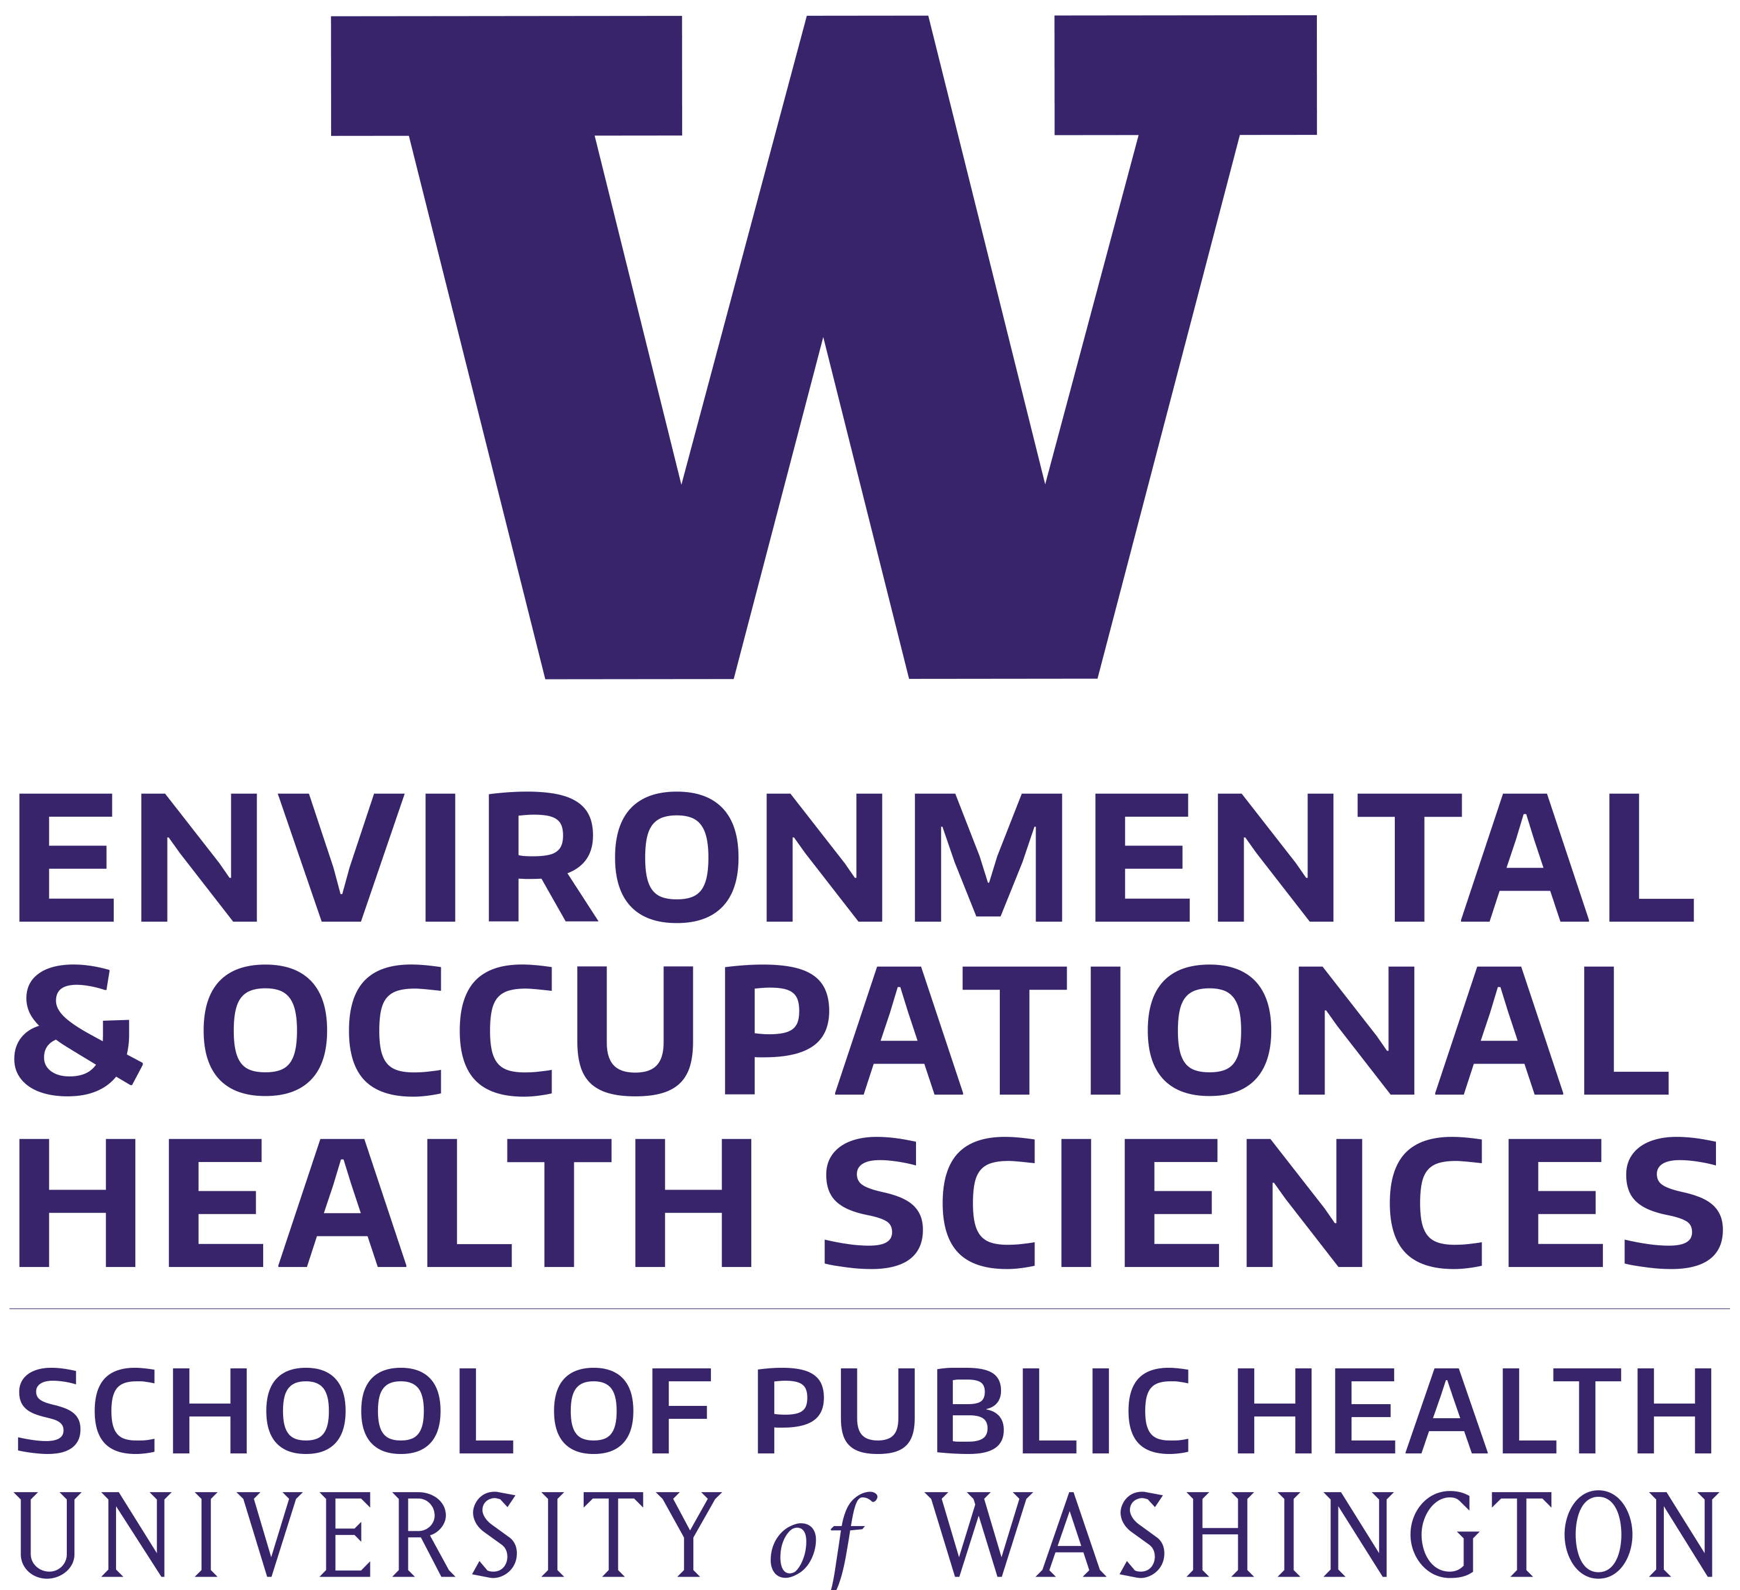

February 2022

Selander, et. al., Full-time exposure to occupational noise during pregnancy was associated with reduced birth weight in a nationwide cohort study of Swedish women. Science of The Total Environment, V 651, P 1, 2019.
Lissaker, et. al., Occupational exposure to noise in relation to pregnancy-related hypertensive disorders and diabetes. Scand J Work Environ Health. 2021 Jan 1; 47(1): 33–41.
Sultan T. Male infertility among bakers associated with exposure to high environmental temperature at the workplace. J Taibah Univ Med Sci. 2018 Apr; 13(2): p103–107.
L. Konkel. Taking the Heat: Potential Fetal Health Effects of Hot Temperatures, Environ Health Perspect. 2019;127(10):102002
Skroder et. al. Occupational exposure to whole body vibrations and birth outcomes - A nationwide cohort study of Swedish women. Sci Total Environ. 2021, Jan 10;751:141476
American College of Obstetricians and Gynecologists, Obstetrics and Gynecology, V131, N4, Apr 2018, e115 – e123

