ENV H 451/551
Environmental & Occupational Health Microbiology I:
Ecology of Environmentally Transmitted Microbial Hazards
Winter Quarter 2025
Monday, Wednesday, and Friday, 10:30-11:20
HSEB 245

INSTRUCTOR: John Scott Meschke (He/Him/His)
Office: 4225 Roosevelt Way NE, Suite 2337
Phone: (206) 221-5470
Email: jmeschke@uw.edu

TA: Alaine Warren (She/Her) (alainekw@uw.edu)

OFFICE HOURS: By appointment

COURSE WEBSITE: https://canvas.uw.edu/courses/1786422/pages/home-page

Land Acknowledgement: The university of Washington acknowledges the Coast Salish people of this land, the land which touches the shared waters of all tribes and bands within the Duwamish, Suquamish, Tulalip and Muckleshoot nations.
Illness protocol: Winter quarter is a time of increased risk of acquiring respiratory illnesses including COVID, RSV, cold, and flu.
If you feel ill or exhibit respiratory or other symptoms, you should not come to class. Seek medical attention if necessary and notify your instructor(s) as soon as possible by email. Follow the COVID-19 Public Health Flowchart if you have COVID-19 symptoms, exposure or test positive, and adhere to the UW Face Covering Policy.
Additional recommendations include getting your annual flu shot and getting boosted with the updated COVID vaccines (available at clinics and pharmacies, as well as through UW Medicine and local health agencies).
Please check your email and CANVAS announcements daily BEFORE coming to class. If we need to conduct class remotely because the instructor or a guest speaker is unable to attend in person, we will send all registered students an email and/or post a CANVAS announcement with a Zoom link for remote instruction or a plan for making up the class.
COURSE DESCRIPTION: This course will review environmentally transmitted pathogens with respect to their sources and occurrence, mobility, and fate in the environment. This course will be of use for public health and health care professionals, microbiologists, civil and environmental engineers, environmental scientists and bio-defense specialists.
COURSE OBJECTIVES: On completion of this course, students should be able to:
1. Recognize and describe the major classes of environmentally transmitted pathogens and other microbiological hazards;
2. Distinguish infectious disease epidemiology from other types of epidemiology;
3. Recognize and assess exposure pathways and routes of transmission;
4. Outline and distinguish the factors affecting the persistence, fate and mobility of microbial hazards in environmental media; and
5. Summarize and discuss relevant research articles on environmental transmission of microbiological hazards.
In addition, graduate students should be able to:
1. Identify and define factors in an exposure scenario that may affect risk from microbiological hazards.
2. Critically review and interpret the scientific and gray literature on microbiological hazards; and
3. Effectively communicate (in oral and written manner) their knowledge of environmental transmission of microbiological hazards.

TEXTS AND REFERENCES: There is no required text for this class. Readings and course materials will be available through Canvas. The following texts are recommended references for more in-depth detail on course topics:

Books-
Manual of Environmental Microbiology 4th edition (ed. Yates et al., ASM Press) Disinfection, Sterilization and Preservation, 5th edition, LWW
Metcalf and Eddy’s Wastewater Engineering: Treatment and Reuse, McGraw-Hill
Water Quality and Treatment, 5th edition, AWWA Bioaerosols Handbook, Lewis
Food Microbiology, Doyle
Any Basic Microbiology Text (e.g. Madigan, Martinko and Parker; Prescott, Harley and
Klein; etc.)

Journals-
Journal of Applied Microbiology
Letters in Applied Microbiology
Applied and Environmental Microbiology Journal of American Water Works Association Journal of Food Protection
International Journal of Food Microbiology
Water Science and Technology
Water Research
Emerging Infectious Disease

PACKBACK: This course will make use of PACKBACK, an instructional AI supported online writing and discussion platform, for developing critical thinking, curiosity, and writing skills. There is a small registration fee associated with PACKBACK. If you have any hardship that prevents you from registering with PACKBACK, please let me know and we can discuss how to access Dean’s office or PACKBACK scholarship opportunities.

COURSE FORMAT: The course will be organized in modules. Much of the didactic lecture material will be available asynchronously online. However, course will meet in person for in-class group discussions and learning activities. Students are expected to attend class and participate.

GRADING OPPORTUNITIES:
For the sake of this class, letter and numerical grades will typically be distributed according to the university grading scale between the following standards:
A(4.0)= Excellent and exceptional work (typically >95% of available points)
D (1.0) = Deficient work (typically <66% of available points)
It is expected that most students will perform at a level of ~3.5.

PLEASE NOTE: Since this course has concurrent undergraduate and graduate sections, and because Canvas does not facilitate separate scoring for different sections, grades in the grade book may not be accurate. Gradebook entries will reflect the score on individual assignments, but the overall grades will be calculated based on the weighting indicated below for each the undergraduate and graduate sections.

Undergraduate Students
Points will be available according to the following percentage breakdown:
Introduction Video (5%): Each student is required to submit a 1-2 minute long introduction video. The video should indicate the students name, what they like to be called, what degree program they are in, any experience they have that is relevant to the class, and what they hope to get out of the class. Students that do not have the capacity to record a video (though most should on their phones) may submit a 1-2 page long statement describing the same information. Videos/Statements will be due by the beginning of the third class period.
Quizzes (20%): Students will have the opportunity to complete 6 quizzes. Quizzes will be due at 11:59 pm on the night before the next class period after the quiz opens. Late quizzes may be penalized 10% of point value for each class period that they are late.
Midterm Exam (20%): Midterm exam will consist primarily of short answer questions, but may include multiple choice and fill-in the blank questions as well. Exams will be conducted online. Exam will be open book and open note. Early or make-up exams will only be offered in case of emergencies or prior arrangement with instructor. Formats for early and make-up exams are left to the discretion of instructor.
In-Class and PACKBACK Discussions (20%): Students may earn points by participating in both in-class group discussions and follow-up PACKBACK-based discussions.
In the News (3%): Student may earn points by providing a current news article focused on a topic relevant to the class for each of the “In the News” sessions, and contributing to group discussion on the topic. No credit will be provided for topics that are not relevant to the class.
Pathogen Profile (10%): Students will have the opportunity to complete a pathogen profile for a “pet bug”. These will be a 3-5 page report submitted through PACKBACK following a provided rubric describing the transmission of their chosen organism by environmental routes and factors that affect it.
Questions for Graduate Panel (2%): Undergraduate students will have the opportunity to earn 2% of their grade by formulating and submitting questions for each graduate student in the graduate student panels based on the graduate students’ pathogen profile videos.
Final Exam (20%): Final Exam will be offered ONLINE during finals week. Final exam will be comprehensive and will consist of short answer multiple choice, true/false-explain, and problem-solving questions. Exam will be open book and open note.

Graduate Students
Points will be available according to the following percentage breakdown:
Introduction Video (5%): Each student is required to submit a 1-2 minute long introduction video. The video should indicate the students name, what they like to be called, what degree program they are in, any experience they have that is relevant to the class, and what they hope to get out of the class. Students that do not have the capacity to record a video (though most should on their phones) may submit a 1-2 page long statement describing the same information. Videos/Statements will be due by the beginning of the third class period.
Quizzes (20%): Students will have the opportunity to complete 6 quizzes. Quizzes will be due at 11:59 pm on the night before the next class period after the quiz opens. Late quizzes may be penalized 10% of point value for each class period that they are late.
Midterm Exam (20%): Midterm exam will consist primarily of short answer questions, but may include multiple choice and fill-in the blank questions as well. Exams will be conducted online. Exam will be open book and open note. Early or make-up exams will only be offered in case of emergencies or prior arrangement with instructor. Formats for early and make-up exams are left to the discretion of instructor.
Group Discussions (15%): Students may earn points by participating in both in-class group discussions and follow-up PACKBACK-based discussions.
Pathogen Profile (20%): Students have the opportunity to complete a pathogen profile for their “pet bug” in the form of a 10 page report submitted through PACKBACK following a provided rubric. Students will also provide an in-class presentation on their report to the class. These will be a 10-15 minute presentations addressing points in the pathogen profile rubric, and participation in a graduate student panel to answer questions posed by undergraduates.
Final Exam (20%): Final Exam will be offered ONLINE during finals week. Final exam will be comprehensive and will consist of short answer multiple choice, true/false-explain, and problem-solving questions. Exam will be open book and open note.

Course Schedule
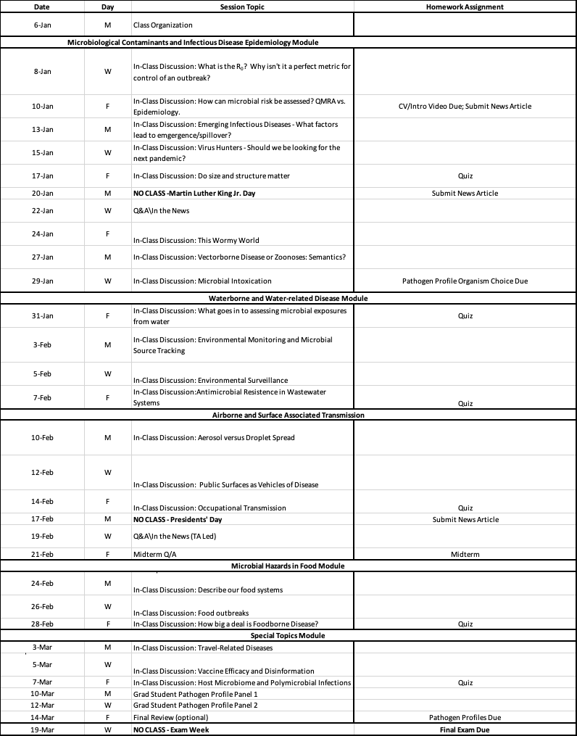

Student Responsibilities
Students are expected to:
- complete pre-session readings (or watch assigned videos) before class,
- attend in-person class sessions and participate in in-class activities
- turn-in all assignments on schedule
- Respectfully listen and actively participate in class
Outside of class, students should use email (not Canvas) to communicate with Instructor and TA (please copy both on all communications, with ENVH 451/551 in subject line). Students should notify instructor in advance of any expected absences.

Important Policies & Resources

Communication and Writing Skills
Communication through writing and speaking is an important transferable skill for all career pathways. Establishing a strong foundation in communication skills will help you be successful throughout your future course work and career. Therefore, this course includes assignments with the goal to help you identify areas of strength and improvement in your communication. If you feel that you could benefit from additional opportunities to improve your writing skills in particular, a list of resources at the UW and others accessible online can be found on the SPH website here.

Academic Integrity
Students at the University of Washington (UW) are expected to maintain the highest standards of academic conduct, professional honesty, and personal integrity.
The UW School of Public Health (SPH) is committed to upholding standards of academic integrity consistent with the academic and professional communities of which it is a part. Plagiarism, cheating, unauthorized use of artificial intelligence (AI) tools, and other misconduct are serious violations of the University of Washington Student Conduct Code (WAC 478-121). We expect you to know and follow the university's policies on cheating and plagiarism, and the SPH Academic Integrity Policy. Any suspected cases of academic misconduct will be handled according to University of Washington regulations. For more information, see the University of Washington Community Standards and Student Conduct.

Use of Generative Artificial Intelligence in Coursework
Artificial Intelligence (AI) content generators, such as ChatGPT, present opportunities that can contribute to your learning and academic work. However, using these technologies may also violate academic standards of the University. Under the Student Conduct Code, cheating includes the unauthorized use of assistance, including technology, in completing assignments or exams.
In this course, the use of AI is not encouraged. However, students may use AI tools to assist with group discussion assignments, and their pathogen profile assignment if needed. If using AI tools on any allowed assignment, student must also submit:
1) Use track changes to demonstrate how much of the written product was written by generative AI, and how much was written by you.
2) Maintain a history within the AI tool of your prompts, inputs, and outputs (for example the chat history in ChatGPT).
3) Provide a written statement including the following.
a. Describe how you used generative AI in the assignment or project.
b. Describe how you verified outputs were correct or true.
Use of AI on quizzes/exams, or in any manner inconsistent with this policy is expressly forbidden and such use will be treated as a violation of the student conduct code and may result in a failing grade or a request to resubmit.

Access and Accommodations
Your experience in this class is important to me. It is the policy and practice of the University of Washington to create inclusive and accessible learning environments consistent with federal and state law. If you have already established accommodations with Disability Resources for Students (DRS), please activate your accommodations via myDRS so we can discuss how they will be implemented in this course.
If you have not yet established services through DRS, but have a temporary health condition or permanent disability that requires accommodations (conditions include but not limited to; mental health, attention-related, learning, vision, hearing, physical or health impacts), contact DRS directly to set up an Access Plan. DRS facilitates the interactive process that establishes reasonable accommodations. Contact DRS at disability.uw.edu.

Religious Accommodations
Washington state law requires that UW develop a policy for accommodation of student absences or significant hardship due to reasons of faith or conscience, or for organized religious activities. The UW’s policy, including more information about how to request an accommodation, is available at Religious Accommodations Policy (https://registrar.washington.edu/staffandfaculty/religious-accommodations-policy/). Accommodations must be requested within the first two weeks of this course using the Religious Accommodations Request form (https://registrar.washington.edu/students/religious-accommodations-request/).

Inclusion & Diversity
Diverse backgrounds, embodiments and experiences are essential to the critical thinking endeavor at the heart of University education. In SPH, we are expected:
- To respect individual differences, which may include, but are not limited to, age, cultural background, disability, ethnicity, family status, gender, immigration status, national origin, race, religion, sex, sexual orientation, socioeconomic status and veteran status.
- To engage respectfully in the discussion of diverse worldviews and ideologies embedded in course readings, presentations and artifacts, including those course materials that are at odds with personal beliefs and values.
- To encourage students with concerns about classroom climate to talk to their instructor, adviser, a member of the departmental or SPH EDI Committee, the Assistant Dean for EDI, or the program’s director.

Classroom Climate
We are co-creators of our learning environment. It is our collective responsibility to develop a supportive learning environment for everyone. Listening with respect and an open mind, striving to understand others’ views, and articulating your own point of view will help foster the creation of this environment. We engage our differences with the intent to build community, not to put down the other and distance our self from the other. Being mindful to not monopolize discussion and/or interrupt others will also help foster a dialogic environment.
The following guidelines can add to the richness of our discussion:
- We assume that persons are always doing the best that they can, including the persons in this learning environment.
- We acknowledge that systematic oppression exists based on privileged positions and specific to race, gender, class, religion, sexual orientation, and other social variables and identities.
- We posit that assigning blame to persons in socially marginal positions is counter-productive to our practice. We can learn much about the dominant culture by looking at how it constructs the lives of those on its social margins.
- While we may question or take issue with another class member’s ideology, we will not demean, devalue, or attempt to humiliate another person based on her/his experiences, value system, or construction of meaning.
- We have a professional obligation to actively challenge myths and stereotypes about our own groups and other groups so we can break down the walls that prohibit group cooperation and growth.
[Adapted from Lynn Weber Cannon (1990). Fostering positive race, class and gender dynamics in the classroom. Women Studies Quarterly, 1 & 2, 126-134.]
We are a learning community. As such, we are expected to engage with difference. Part of functioning as a learning community is to engage in dialogue in respectful ways that supports learning for all of us and that holds us accountable to each other. Our learning community asks us to trust and take risks in being vulnerable.
Here are some guidelines that we try to use in our learning process:
- LISTEN WELL and be present to each member of our group and class.
- Assume that I might miss things others see and see things others miss.
- Raise my views in such a way that I encourage others to raise theirs.
- Inquire into others’ views while inviting them to inquire into mine.
- Extend the same listening to others I would wish them to extend to me.
- Surface my feelings in such a way that I make it easier for others to surface theirs.
- Regard my views as a perspective onto the world, not the world itself.
- Beware of either-or thinking.
- Beware of my assumptions of others and their motivations.
- Test my assumptions about how and why people say or do things.
- Be authentic in my engagement with all members of our class.

Pronouns
We share our pronouns because we strive to cultivate an inclusive environment where people of all genders feel safe and respected. We cannot assume we know someone’s gender just by looking at them. So we invite everyone to share their pronouns.

Bias Concerns
The Office of the Dean has a student concern policy, a faculty concern policy and standard HR procedures for staff concerns. Our 2018 climate survey states that most people in SPH do not report bias incidents because they do not know where to go. Students are encouraged to report any incidents of bias to someone they feel comfortable with, including instructors, advisers or department staff. They can email dcinfo@uw.edu for immediate follow up. Bias concerns can be anonymously and confidentially reported via the online form found here: https://sph.washington.edu/about/diversity/bias-concerns. Data is collected by the Assistant Dean for EDI and the Director of Program Operations for Student and Academic Services and tracked for resolution and areas are identified for further training.

Sexual Harassment
Sexual harassment is a form of harassment based on the recipient’s sex that is characterized by:
- Unwelcome sexual advances, requests for sexual favors, or other verbal or physical conduct of a sexual nature by a person who has authority over the recipient when:
  - Submission to such conduct is an implicit or explicit condition of the individual’s employment, academic status, or ability to use University facilities and services, or
  - Submission to or rejection of the conduct affects tangible aspects of the individual’s employment, academic status, or use of University facilities.
- Unwelcome and unsolicited language or conduct that creates an intimidating, hostile, or offensive working or learning environment, or has the purpose or effect of unreasonably interfering with an individual’s academic or work performance.

If you believe that you are being harassed, or have observed harassment, you can report it to SPH using the bias concerns link. The University also has designated offices to help you: SafeCampus; Office of the Ombud; Title IX Investigation Office; and University Complaint Investigation and Resolution Office.

