FINAL REPORT

Feasibility study to guide the development of a wet bulb globe temperature-based
heat alert system aimed at heat‐related illness prevention and
productivity optimization in agricultural workers

Jennifer Krenz, MS, MPH Miriam Calkins, MS June Spector, MD, MPH

University of Washington
School of Public Health
Department of Environmental & Occupational Health Sciences

September 2015

ACKNOWLEDGMENTS
Funding for this project has been provided by the Medical Aid and Accident Fund, administered by the University of Washington Department of Environmental and Occupational Health Sciences.
We worked in collaboration with Dr. Gerrit Hoogenboom, Director and Professor, AgWeatherNet Program, Washington State University.

Special thanks to our partners:

- Dr. Gerrit Hoogenboom, Director and Professor, AgWeatherNet Program, Washington State University
- Sean Hill, Application Systems Analyst/Developer, AgWeatherNet Program, Washington State University
- Pablo Palmández, Communication Workplace Specialist, Pacific Northwest Agricultural Safety and Health Center
- Participating growers, managers, and health & safety specialists

CONTACT INFORMATION
June Spector
Departments of Environmental & Occupational Health Sciences and Medicine

Address:
University of Washington
Box 354695
4225 Roosevelt Way NE
Suite 100
Seattle, WA 98105

Telephone: (206) 897-1979
Email: spectj@uw.edu
TABLE OF CONTENTS
1 PLAIN LANGUAGE SUMMARY 5
2 BACKGROUND 7
3 METHODS 10
3.1 Phase 1 10
3.2 Phase 2 10
3.3 Phase 3 11
4 RESULTS 13
4.1 Phase 1 13
4.2 Phase 2 14
4.3 Phase 3 17
5 CONCLUSIONS & RECOMMENDATIONS 25
5.1 Conclusions 25
5.2 Recommendations 27
6 REFERENCES 30
7 APPENDICES 33
7.1 Appendix I: Key informant interview forms (farms & other) 33
7.2 Appendix II: Key informant interview recruitment e-mail 40

LIST OF FIGURES

Figure 1. Locations of instrumented (black globe, air pressure sensors) AgWeatherNet weather stations (p. 13)
Figure 2. Prototype user interface of sensor data integrated into AgWeatherNet portal (p. 14)
Figure 3. Heat exposure indices (degrees Celsius) on June 22, 2015 at the Naches AgWeatherNet weather station (p. 15)
Figure 4. Comparison of Humidex and heat index (degrees Celsius) on June 22, 2015 and July 3, 2015 at the Naches AgWeatherNet weather station (p. 16)
Figure 5. Comparison of WBGT calculated from black globe temperature and other sensors and WBGT estimated from standard meteorological data (degrees Celsius) using the methods of Liljegren et al¹ on June 22, 2015 and July 3, 2015 at the Naches AgWeatherNet weather station (p. 17)

PLAIN LANGUAGE SUMMARY
Washington (WA) crop workers are at risk for heat-related illness (HRI) from exposure to hot conditions and internal heat generation from heavy physical work. Research suggests that systems that inform people about hot conditions may be effective in preventing HRI. This project sought to collaborate with growers and others in the WA agricultural community to assess the relative practicality and acceptability of heat awareness approaches using different heat indices, and to explored how best to communicate this information to the agricultural community. To accomplish this goal, we worked with Washington State University’s (WSU) AgWeatherNet Program, which provides access to weather data from WSU’s automated weather station network and a range of models and decision aids, to: 1) install special sensors on several AgWeatherNet weather stations in order to calculate Wet Bulb Globe Temperature (WBGT), a standard index of heat exposure; 2) compare WBGT with estimates of WBGT and other heat indices; and 3) conduct key informant interviews with stakeholders in the agricultural community to identify the preferred uses and features of a heat awareness system. We found that while growers are interested in heat exposure data for crop management and worker health protection, as well as for optimizing work efficiency, heat indices, sources of heat exposure data, and actions in response to heat data appear to vary. We demonstrated that WBGT can be calculated from special weather station sensors but that estimating WBGT from existing sensors using certain methods may be adequate from a worker health and safety standpoint. While estimated WBGT values could form the basis for determining when to send out information about hot conditions to the agricultural community, WBGT values should be coupled data that many growers currently prefer, such as air temperature and humidity, and communications should include or direct recipients to information on standard recommended practices to protect worker health in the heat, tailored to the WA growing community. This project identified an opportunity and specific next steps for reducing disparities in heat health practices and worker HRI risk and laid the groundwork for the development of a heat awareness system aimed at preventing HRI and heat-associated injuries, while optimizing productivity, in WA agricultural workers.

BACKGROUND
Agriculture, a $49 billion cornerstone of Washington’s (WA) economy with approximately 160,000 workers,² is characterized by outdoor work such as farmwork and high rates of exertional heat-related illness (HRI) and fatalities, particularly during warm summer months.^{3–5} Exertional HRI can occur in young, otherwise healthy individuals with high metabolic output rates from heavy physical work. From 2003 to 2008, the US agriculture, forestry, and fishing sector had the highest mean heat fatality rate, and the majority of these fatalities occurred in relatively young workers in the crop production and support subsectors.³ In WA, where crop workers are largely seasonal, foreign-born, Spanish-speaking workers, the average annual incidence rate per 100,000 FTE for third quarter (July-September, 1995-2009) HRI workers’ compensation claims was 15.7, a likely underestimate due to under-reporting to the workers’ compensation system.⁶ In addition to HRI, occupational heat stress is associated with increased injury risk^{7,8} and decreased work capacity due to the body’s natural response to reduce physical work intensity and internal heat generation, although this response may be overridden by external incentives such as piece rate pay.⁹ Crop workers are already at high risk for HRI, and projected increases in the frequency and intensity of heat waves due to climate change threaten to increase this risk further.¹⁰
Our previous work with WA agricultural workers indicates that, in addition to strategies aimed at individual worker risk factor reduction, workplace- and population-level prevention strategies are needed to effectively prevent heat-related illness and injuries.¹¹ Workers often do not have control over workplace factors, such as work-rest cycles and cooling mechanisms, which influence heat-related illness and injury risk. Studies suggest that heat warning systems may be effective in preventing classical HRI in the general population,¹² but less work has been done to develop and evaluate heat warning systems, tailored to crop workers, that aim to reducing the risk of exertional HRI. Such systems may help support employer decisions around HRI prevention and productivity optimization, for example to organize physically intensive work during earlier cooler parts of the day and implement other heat stress controls.
The benefits and drawbacks of using different indices aimed at occupational heat illness and injury prevention in crop workers, and corresponding thresholds for heat alerts, have not to our knowledge been systematically evaluated. Even in the general population, different indices and thresholds have been used in different heat warning systems.¹³ A multitude of empirical^{14–16} and rational^{17–20} occupational heat indices have been developed, including the most widely-accepted index, the wet bulb globe temperature (WBGT). The WBGT uses measures of the natural wet bulb temperature, black globe temperature, and air temperature to indirectly capture information about radiant temperature, air velocity, and humidity, key factors in determining occupational heat stress.²¹ The WBGT has been adopted in workplace heat safety guidelines published by the International Organization for Standardization (ISO)²² and the American Conference for Governmental Industrial Hygienists (ACGIH),²³ where it serves as a measure of heat stress when considered together with activity and clothing. The WBGT can also be estimated, with varying levels of accuracy depending on circumstances and specific methods, from standard meteorological data.^{24–26,1} Other measures of heat exposure include the National Oceanographic and Atmospheric Administration (NOAA)’s Heat Index system, which is simpler to use than the WBGT, is the basis for NOAA’s Heat Advisory System (http://www.nws.noaa.gov/os/heat/index.shtml#wwa), and has been adapted by the US Occupational Safety and Health Administration (OSHA) for occupational populations (https://www.osha.gov/SLTC/heatillness/heat_index/index.html). Humidex, which is similar to the Heat Index, but based on dew point rather than relative humidity, has been developed and used in Canada,²⁷ including for occupational applications (http://www.ccohs.ca/oshanswers/phys_agents/humidex.html). However, the heat index and Humidex only take into account air temperature and humidity/dew point.
In this project, we assessed the relative practicality and acceptability of heat alert approaches using indices such as the WBGT and explored how best to communicate this information to the agricultural community. We focused on real-time heat alerts as a foundation for future work on heat warning systems that could utilize high-resolution weather prediction models and recommend adaptive responses. Our goal was to lay the groundwork for the development of a heat warning system aimed at reducing the risk of HRI and heat-related injuries in WA agricultural workers.

METHODS
To achieve project goals during the nine-month project period (official project dates October 6, 2014 to June 30, 2015, although work extended into September 2015), project work was organized into three phases. Given a heat wave that occurred early in the summer, and the continuation of our work throughout the summer, we were able to conduct our work during representative summer conditions.

Phase 1
In Phase 1, Campbell Scientific black globe temperature and air pressure sensors were purchased by our collaborators at Washington State University (WSU), evaluated for calibration in the WSU AgWeatherNet calibration yard, installed on weather stations in Central/Eastern WA agriculturally intensive regions, and data from the sensors (including WBGT) were integrated into the AgWeatherNet portal. AgWeatherNet provides access to current and historical weather data from WSU’s automated weather station network, which is comprised of over 160 WA weather stations, along with a range of models and decision aids, including e-mail alerts and text messages regarding certain weather conditions available to registered users (http://weather.wsu.edu).

Phase 2
In Phase 2, direct WBGT measures from weather stations instrumented in Phase 1 were descriptively compared with WBGT estimated from standard meteorological data from these weather stations and with heat index, Humidex, and air temperature. Wet bulb globe temperature, heat index,^{28,29} and Humidex were calculated using standard methods.^{21,27–29} We used the methods of Liljegren et al to estimate WBGT.¹ Of note, although a Windows executable program (Version 1.2) written in Fortran and C with a graphical user interface is available directly from Liljegren to perform estimated WBGT calculations in an automated fashion, the calculator relies on manual input of values one at a time. No publically available
batch WBGT calculator using the Liljegren method currently exists that we are aware of, so estimated WBGT values were manually computed one at a time. We compared WBGT, estimated WBGT, Humidex, heat index, and air temperature values over the course of selected days at selected weather stations graphically and using descriptive statistics.

Phase 3
In Phase 3, key informant interviews with stakeholders in the agricultural community were conducted to identify the preferred uses and features of a heat warning system. Two interview forms were developed for key informant interviews (Appendix I). One form was tailored toward farm managers and owners, and the other form was tailored toward representatives of different government, nonprofit, and industry groups that work in agriculture. The questions covered existing heat safety practices, challenges to heat illness prevention, and preferred uses and features of a heat warning system. Individuals were recruited for interviews using several approaches. An email was sent out via the AgWeatherNet listserv advertising the project (Appendix II). The project was also advertised in the July 2015 issue of the Voice of the Vine, a blog for the viticulture industry published by WSU. Interested companies and individuals emailed or called the research team, and times were scheduled for interviews. The research team also contacted individuals with whom they had established relationships through previous work on Pacific Northwest Agricultural Safety and Health (PNASH) projects. All key informant interviews were conducted over the phone by the University of Washington (UW) research team. The responses to questions by each individual were recorded on interview forms, and all responses were aggregated and summarized. All project activities were approved by the UW Human Subjects Division, and all participants provided informed consent.

RESULTS

Phase 1
Campbell Scientific black globe temperature and air pressure sensors were installed on the following AgWeatherNet weather stations: Naches [Latitude 46.70, Longitude -120.66], North Pasco [Latitude 46.38, Longitude -119.25], Vantage [Latitude 46.82, Longitude -119.94], and WSU Prosser [Latitude 46.26, Longitude -119.74] & WSU Tree Fruit Research and Education Sunrise Orchard [Latitude 47.31, Longitude -120.07] (Fig 1).
Figure 1. Locations of instrumented (black globe, air pressure sensors) AgWeatherNet weather stations.
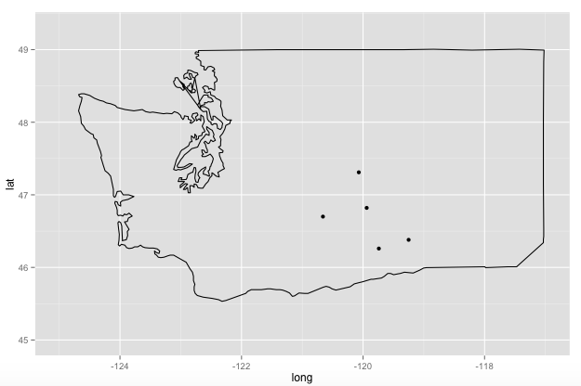
Data from the sensors were integrated into the AgWeatherNet portal and used to calculate WBGT, and a prototype user interface was developed (Fig 2). The interface allows visualization of the air temperature, wet bulb temperature, black globe temperature, dewpoint, and WBGT at 15 minutes intervals at each of the stations (http://weather.wsu.edu/awn.php?page=blackglobe).

Figure 2. Prototype user interface of sensor data integrated into AgWeatherNet portal (http://weather.wsu.edu/awn.php?page=blackglobe).
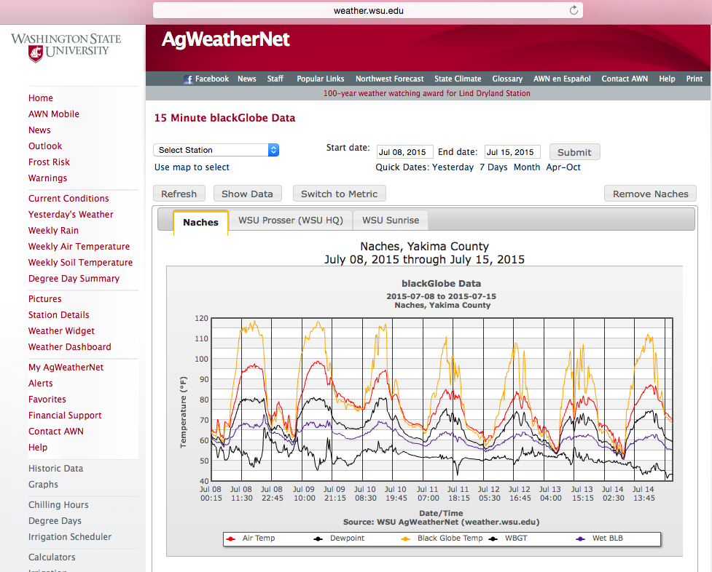

Phase 2
Air temperature, WBGT, WBGT estimated from standard meteorological data using the methods of Liljegren et al,¹ Humidex, and heat index appeared to be closely related, as illustrated in Fig 3, which describes data from the Naches station on June 22, 2015.

Figure 3. Heat exposure indices (degrees Celsius) on June 22, 2015 at the Naches AgWeatherNet weather station.
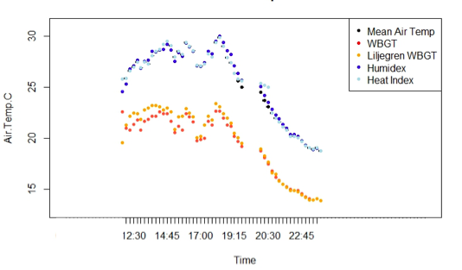
In particular, on June 22 and July 3, 2015 at the Naches weather station, heat index and Humidex were highly correlated (Fig 4), as were WBGT calculated from black globe temperature and other sensors and WBGT estimated using standard meteorological data (Fig 5). WBGT and air temperature (Spearman’s rho = 0.97, p<0.0001) and WBGT and Humidex (Spearman’s rho = 0.99, p<0.0001), from June 22 to July 26, 2015 at the Naches weather station, were also highly correlated.

Figure 4. Comparison of Humidex and heat index (degrees Celsius) on June 22, 2015 and July 3, 2015 at the Naches AgWeatherNet weather station.
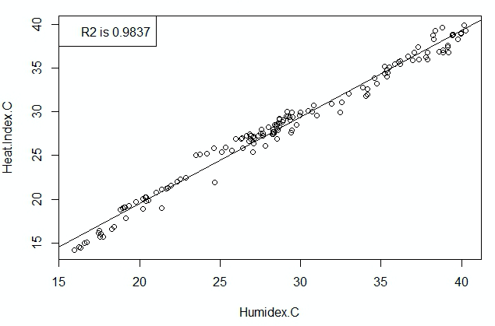

Figure 5. Comparison of WBGT calculated from black globe temperature and other sensors and WBGT estimated from standard meteorological data (degrees Celsius) using the methods of Liljegren et al¹ on June 22, 2015 and July 3, 2015 at the Naches AgWeatherNet weather station.

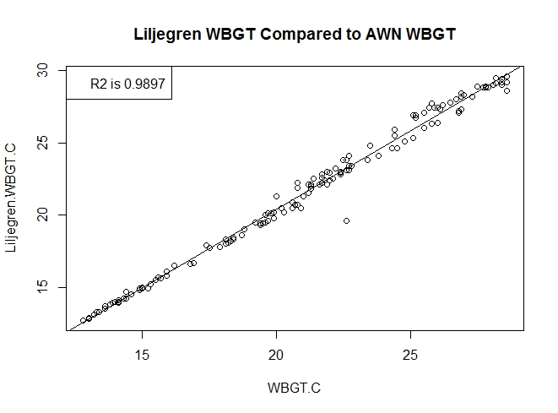

Phase 3
A total of 13 interviews were conducted between July and September of 2015. Ten of the 13 individuals identified themselves as owners, managers, or crew supervisors on farms. There were two vineyard operations and eight tree fruit operations (growing various combinations of apples, pears, and cherries). The number of employees on these operations varied by farm and by season, with increased numbers of workers during thinning and harvesting periods. During non-peak work times, the number of employees working at the farms ranged between three to 100 workers, with a median of 22 workers. During peak work times (thinning and harvesting), the number of employees ranged from 20 to 250 workers, with a median of 50 workers. The number of workers during thinning and harvesting ranged from three to ten times the number of workers during other times.
Of the three other individuals interviewed, two were health and safety specialists with their organizations (one with a nonprofit and one with a government agency), and one was the human resources director at a packing company. Of note, the term “heat awareness system” was selected for communications about the project, as there was concern that “heat alert” or “heat warning” would be erroneously conflated with WA heat rule regulations and citations,³⁰ which were not the topic of this project.
Heat and productivity
When asked how hot weather affects the quality of work on farms, most farm representatives responded that it is not so much the quality of work as efficiency. When workers are tired and hot, their pace slows, which impacts worker efficiency. Participants mentioned that workers complain, cannot accomplish all the tasks assigned to them, and spend more time seeking shade. At one workplace where workers are paid hourly year-round, the participant stated that workers take longer and more frequent breaks, which makes the workers less efficient. At a workplace where workers are paid piece rate during harvest, the farm representative stated that workers pick more when the weather is cool and the hot weather slows them down. When it is hot, workers stop earlier in the day which impacts the amount harvested and the number of rows completed (e.g. not as many trees thinned). One participant responded that they only hire “productive” workers, so they do not have any issues with efficiency and productivity. Worker productivity and efficiency is measured by the number of completed rows for tasks like canopy management and thinning, and number bins or boxes picked for tasks like harvesting.
Heat and worker safety
All participants voiced concern about workers developing heat illness when the weather is hot. One participant specified they were more anxious about older workers, and one participant mentioned that they were concerned with injuries that might occur if workers get dizzy and fall off ladders. Practices to prevent heat illness that were mentioned by farm representatives included instructing workers to stop when the temperature gets too hot, starting working earlier and asking workers to return in the late afternoon/early evening, providing drinking water, reminding workers to stay hydrated, advising workers to wear light clothing for work, giving workers tasks that can be completed in the shade, giving workers light work that do not require as much skill or concentration, asking workers to take more breaks, and conducting more safety meetings. Participants also mentioned that they ask workers to protect their skin from the sun. One participant stated that they have their employees move to a warehouse to do work (no details were asked about the warehouse).
When it is too hot to work, all participating farms responded that they notify their workers verbally, either through crew leaders/field checkers or directly by upper-level management. At one farm, the manager would check the temperature every 15 minutes when it started to feel hot outside and let the crew chief know when it was above their threshold temperature of 93°F. The crew chief then notified the workers in the field. They recently changed their policy and now instruct workers to quit when they feel uncomfortable, which has led to fewer complaints. All participants stated that workers are allowed to stop working when they choose, though they are not compensated for lost hours due to heat. One farm set up thermometers in the orchard that workers can check to help determine if the temperature is too high for working. At another farm, managers notify the crew in the morning if a hot day is expected.
Six of the ten farm representatives interviewed use heat safety guidelines from WA L&I, two also mentioned using OSHA/WISHA, and two reported not using any heat safety guidelines. Two participants reported using heat illness safety training developed by the WA Growers League and one mentioned using resources from the WA State Farm Bureau. None of the participants reported using guidelines developed by ACGIH or ISO. One participant stated that they tended to pay attention to guidelines from regulatory agencies because they can “crack down.”
Heat and crops
When asked about other concerns related to heat, fruit quality, irrigation, pesticide application timing, and overheating equipment were mentioned. Caution must be taken when thinning because newly exposed fruit is more prone to sun damage and needs time to adjust. One participant stated that the fruit they send to the warehouse turns black when it is too hot. Irrigation is a concern because crops require more water in hot weather, and recent water shortages due to lack of snowpack make it difficult to supply crops with enough water. In addition, overhead irrigation is also turned on in tree fruit to help cool down the air within the orchard. At one workplace, they recently changed the irrigation system to conserve water (now use hoses instead of sprinklers). Pesticide applications become more difficult during hot periods because pesticides cannot be sprayed when the air temperature is 85°F or higher. Farm representatives mentioned changing practices to spray at night to avoid hot temperatures.
Perceptions of changing weather patterns
In response to a question about changing weather patterns, one participant stated that they noticed the summers are getting warmer and the winters are not as cold. As a result, trees are developing more quickly, and blooming and harvesting occur earlier in the season. Before there was more time to accomplish tasks and local workers could be hired, and now certain tasks need to be completed earlier which requires hiring H-2A workers. Another participant mentioned that there has been a third codling moth generation encountered more frequently in recent years that did not commonly occur before. Some participants stated that they have not observed any consistent trends, though there are yearly variations in the weather.
Farm representatives reported making several modifications at the workplace due to changing weather patterns over the years, including starting work shifts earlier, splitting work shifts into morning and late afternoon, and conducting more training and training crew leaders to watch over employee practices (e.g. encourage employees to drink water instead of energy drinks). One participant stated they were considering hiring additional workers, so they would not fall behind in the tasks that need to be completed.
When asked if records are kept to document changes, most farm representatives referenced pesticide application records that they are required to keep for seven years. Two of the farm representatives stated that they do keep productivity records, one farm has records for about the past ten years and another farm has records for the past three years. One participant did mention that worker schedules had changed since they purchased their farm in 1993 but did not provide information on how well this was documented.
Weather monitoring practices
During the growing season, all participants reported that they check the weather every day and generally multiple times per day. All participants check the air temperature and most check humidity and wind speed as well. One participant also mentioned that they check for the chance of precipitation. Air temperature is generally what is used to determine if the weather is safe for workers, though each workplace has their own high temperature threshold ranging from 85°F to 95°F since there is not a threshold for having workers stop that is specified in regulations (the WA Heat Rule has temperature action levels). Several participants stated that they do consider humidity and wind speed in regards to worker safety, with dry heat and breezy conditions being preferable to high humidity and no wind or strong winds.
All participants reported using the internet and phone applications to check the weather and check the forecast for planning purposes. Two participants specifically mentioned the OSHA weather app. Three participants mentioned using television, three use the radio, one uses the newspaper, and two workplaces get daily weather report printouts from a local agricultural chemical supply company. One participant uses a vehicle thermostat and one uses a handheld meter. One participant uses a customized weather station on their property that was installed by a neighbor. One participant stated that if the predicted high temperature is fairly high, then they know to expect the work day to end early.
Eight of the 13 participants have heard of AgWeatherNet, and six of those have used it to check the weather and/or have signed up to receive alerts for their area. One participant mentioned that they are cautious about using it because of variations in microclimate (i.e. weather station placement may not reflect what is occurring nearby because of differences in topography, vegetation, etc.). Two participants are aware of the location of the AgWeatherNet stations closest to their farms.
Heat awareness system preferences
All but one participant would like to receive information about heat waves and hot days in advance. One participant preferred using the customized weather station installed on their property, which feeds information on temperature, humidity, and wind speed to their home computer. Of the 13 participants, most responded that it would be helpful to have notice about heat waves two or three days in advance for planning purposes. One participant stated that it would be ideal to have a week notice but felt like the predictions may not be accurate that far in advance.
Most participants prefer to receive messages and alerts via text messages, and many also mentioned phone calls as an acceptable way to communicate. One participant mentioned that an automated phone voice message may work better for those who do not have smart phones. Most participants responded that English and Spanish options would be helpful. On many farms upper level management supervises crew leaders, who interact with workers and relay messages. Many of the crew leaders primarily speak and read in Spanish.
It was difficult for participants to estimate how much they would pay for a heat awareness system without experiencing how it would actually work. Most participants stated they would pay for a system if it worked well. One participant stated there is so much information available for free that it would be hard to convince their farm to pay. In general, $10/month during the growing season was a reasonable price for most participants, with the option to opt out without a penalty. One participant also mentioned a flat rate for the season may be acceptable for growers.

CONCLUSIONS & RECOMMENDATIONS

Conclusions
Key informant interviews with WA agricultural stakeholders, including growers, indicated that there is interest and current use of heat exposure data for crop management and worker health protection as well as for optimizing work efficiency. However, heat indices, sources of heat exposure data, and responses to data appear to vary. Interviewed growers reported using air temperature, humidity, and wind speed data obtained from a variety of sources, including the internet, phone applications, television, radio, newspaper, and AgWeatherNet, to make decisions about worker heat practices. Growers additionally reported using different heat thresholds for determining when it was safe for workers to work. The results of this project suggest that there is an opportunity to reduce disparities in heat health practices and worker HRI risk by providing consistent recommendations coupled with desired heat exposure data to the agricultural community.
Although this project demonstrated that WBGT can be calculated using sensors such as black globes on existing AgWeatherNet weather stations, estimating WBGT using the methods of Liljegren et al¹ is likely adequate from a worker health and safety perspective, and less costly, than instrumenting additional AgWeatherNet weather stations. Wet bulb globe temperatures could form the basis for determining when to send out heat alerts, for example based on ACGIH²³ action limits, but heat communications could be coupled with data that growers are currently more familiar and comfortable with, such as air temperature and humidity. Displaying several (but not too many) heat indices in a communication may provide an opportunity for growers to become familiar with indices that enjoy more supporting data relevant to worker health and safety (e.g. WBGT). Along with data on heat indices, communications should include or direct recipients to information on standard recommended practices to protect worker health in the heat, tailored to the WA growing community.
Interviewed growers were interested in receiving information about hot conditions, including via text message or automated phone message, and indicated an interest in ultimately receiving information several days to a week in advance for planning purposes. Alerts in Spanish and English are critical to effectively communicate information to crew leaders, who in WA are likely to primarily speak and read in Spanish. Given the influence of microclimates on worker health, and growers’ interest in conditions on their particular farm, alerts should be based on data from weather stations closest to, or within, farms.
The following specific recommendations, in the areas of technical & logistical considerations, communication, and advertisement, should be considered in the development of a heat awareness system aimed at reducing the risk of HRI and heat-related injuries in WA agricultural workers. Such a system should ultimately be evaluated for its effectiveness in reducing disparities in heat health practices and worker HRI risk. Additional funding opportunities are currently being pursued for further development and evaluation of a heat awareness system for WA agriculture, and reporting of the results described in this report back to participating stakeholders is underway.

Recommendations
Technical & logistical considerations:
- Use the methods of Liljegren et al¹ to estimate WBGT from standard meteorological data; instrumentation of additional weather stations with wet bulb globe and air pressure sensors is probably not necessary
  - Work with Liljegren to develop “real-time” WBGT estimates within the AgWeatherNet System from existing Liljegren WBGT equation C code
- Set thresholds for messages based on WBGT (e.g. ACGIH²³ action limits), and couple WBGT with indices that growers are currently more familiar and comfortable with
  - Send messages when these thresholds are reached
  - Provide air temperature, humidity, heat index, wind speed, and possibly chance of precipitation, in addition to the WBGT
  - Provide a clear explanation of what the WBGT is and why it is a recommended threshold metric for worker health and safety
- Couple data on heat indices with practical information on standard recommended practices to protect worker health in the heat, such as those available through OSHA (https://www.osha.gov/SLTC/heatillness/heat_index/index.html) and ACGIH,²³ tailored to the WA growing community
  - These messages with recommendations can serve as “fact sheets” for the grower community on how to optimize worker health and productivity in current or predicted hot conditions
- Collaborate with the WA Department of Labor and Industries and organizations such as the WA Growers League to develop messaging that meets regulations and involves groups that farms respect and look to for resources, in addition to established workplace safety & health guidelines
  - Consider also collaborating with organizations such as GlobalGap that many farms work with to meet food safety standards (or at least be aware of their program requirements)
- Offer the heat awareness service for free if financially feasible
  - Consider making it a fee-based service at a later time if there is enough interest
  - Signing up should cost no more than $10/month from May-Sept, with an option to opt out anytime
- Ultimately, utilize high-resolution weather prediction models and send out multiple messages about hot conditions in advance
  - Send a brief message if a hot conditions are expected within a week
  - Send more detailed information with health and safety tips two or three days in advance, when there is more certainty regarding temperatures and timing
  - Send out follow-up reminders the day before and morning of hot conditions
Communication:
- Use the term “heat awareness system” instead of “heat alert system” or “heat warning system,” as such terms may cause concern among growers by brining to mind WA heat rule citations and detract from the focus of optimizing worker health and productivity
- Offer text messages, email, and automated phone calls as ways to receive messages about hot conditions
  - Identify where there is no cell phone reception and determine if there are alternative means of communication
- Offer English and Spanish options so more crew leaders and workers can access information
Advertisement:
- Partner with radio stations to send out messages and alerts
  - Popular radio stations differ by location
  - Consider collaborating with Radio KDNA
  - Be aware that in some areas, only AM stations may be available
- Advertise the heat awareness system in bilingual newspapers (e.g. tú Decides based out of Pasco WA and El Sol de Yakima) to reach a wider audience and to reach those whose primary language is Spanish
- Focus advertisements just prior to peak worker times (e.g. thinning and harvesting) if appropriate (note that thinning and harvesting occur at different times of year depending on the crop and in some cases, these activities occur when the weather is cool (e.g. late winter or fall)
  - Workers that are hired temporarily may not have had prior HRI training and may not be as well acclimated to weather conditions, so reaching these workers is especially important

REFERENCES
1. Liljegren JC, Carhart RA, Lawday P, Tschopp S, Sharp R. Modeling the wet bulb globe temperature using standard meteorological measurements. J Occup Environ Hyg [Internet]. 2008 Oct [cited 2015 Oct 9];5(10):645–55. Available from: http://www.ncbi.nlm.nih.gov/pubmed/18668404
2. Washington State Department of Agriculture. Agriculture: A Cornerstone of Washington’s Economy [Internet]. 2014;Available from: http://agr.wa.gov/AgInWa/
3. Jackson LL, Rosenberg HR. Preventing heat-related illness among agricultural workers. J Agromedicine. 2010 Jul;15(3):200–215.
4. Bonauto D, Anderson R, Rauser E, Burke B. Occupational heat illness in Washington State, 1995-2005. Am J Ind Med. 2007 Dec;50(12):940–950.
5. BLS. Injuries, illnesses, and fatalities [Internet]. 2010 [cited 2015 Oct 9];Available from: http://www.bls.gov/iif
6. Spector J, Krenz J, Rauser E, Bonauto D. Heat-related illness in Washington State agriculture and forestry sectors. Am J Ind Med. 2014;57(8):881–95.
7. Morabito M, Cecchi L, Crisci A, Modesti PA, Orlandini S. Relationship between work-related accidents and hot weather conditions in Tuscany (central Italy). Ind Health [Internet]. 2006 Jul [cited 2015 Oct 9];44(3):458–64. Available from: http://www.ncbi.nlm.nih.gov/pubmed/16922190
8. Tawatsupa B, Yiengprugsawan V, Kjellstrom T, Berecki-Gisolf J, Seubsman S-A, Sleigh A. Association between heat stress and occupational injury among Thai workers: findings of the Thai Cohort Study. Ind Health [Internet]. 2013 Jan [cited 2015 Oct 9];51(1):34–46. Available from: http://www.ncbi.nlm.nih.gov/pubmed/23411755
9. Lundgren K, Kuklane K, Gao C, Holmér I. Effects of heat stress on working populations when facing climate change. Ind Health [Internet]. 2013 Jan [cited 2015 Oct 9];51(1):3–15. Available from: http://www.ncbi.nlm.nih.gov/pubmed/23411752
10. Jackson E, Yost M, Karr C, Fitzpatrick C, Lamb B, Chung S, et al. Public Health Impacts of Climate Change in Washington State: Projected Mortality Risks Due to Heat Events and Air Pollution, Chapter 10. Washingt Clim Chang Impacts Assessment. 2009;
11. Lam M, Krenz J, Palmandez P, Negrete M, Perla M, Murphy-Robinson H, et al. Identification of barriers to the prevention and treatment of heat-related illness in Latino farmworkers using activity-oriented, participatory rural appraisal focus group methods. BMC Public Health [Internet]. 2013 Jan [cited 2015 Oct 9];13:1004. Available from: http://www.pubmedcentral.nih.gov/articlerender.fcgi?artid=4015616&tool=pmcentrez&rendertype=abstract
12. Toloo GS, Fitzgerald G, Aitken P, Verrall K, Tong S. Are heat warning systems effective? Environ Health [Internet]. 2013 Jan [cited 2015 Oct 9];12:27. Available from: http://www.pubmedcentral.nih.gov/articlerender.fcgi?artid=3626939&tool=pmcentrez&rendertype=abstract
13. Lowe D, Ebi KL, Forsberg B. Heatwave early warning systems and adaptation advice to reduce human health consequences of heatwaves. Int J Environ Res Public Health [Internet]. 2011 Dec [cited 2015 Oct 9];8(12):4623–48. Available from: http://www.pubmedcentral.nih.gov/articlerender.fcgi?artid=3290979&tool=pmcentrez&rendertype=abstract
14. YAGLOU CP, MINARD D. Control of heat casualties at military training centers. AMA Arch Ind Health [Internet]. 1957 Oct [cited 2015 Oct 9];16(4):302–16. Available from: http://www.ncbi.nlm.nih.gov/pubmed/13457450
15. Bedford T. Environmental warmth and its measurement. London: 1946.
16. McArdle B, Dunham W, Holling E, etal. The prediction of the physiological effects of warm and hot environments. London: 1947.
17. Belding H, Hatch T. Index for evaluating heat stress in terms of resulting physiological strain. Heat Pip Air Cond. 1955;27:129–36.
18. Vogt JJ, Candas V, Libert JP, Daull F. Bioengineering, Thermal Physiology and Comfort [Internet]. Elsevier; 1981 [cited 2015 Oct 9]. Available from: http://www.sciencedirect.com/science/article/pii/S0166111608710835
19. Malchaire JBM. Occupational heat stress assessment by the Predicted Heat Strain model. Ind Health [Internet]. 2006 Jul [cited 2015 Oct 9];44(3):380–7. Available from: http://www.ncbi.nlm.nih.gov/pubmed/16922181
20. Bröde P, Fiala D, Błażejczyk K, Holmér I, Jendritzky G, Kampmann B, et al. Deriving the operational procedure for the Universal Thermal Climate Index (UTCI). Int J Biometeorol [Internet]. 2012 May [cited 2015 Oct 9];56(3):481–94. Available from: http://www.ncbi.nlm.nih.gov/pubmed/21626294
21. Parsons K. Occupational health impacts of climate change: current and future ISO standards for the assessment of heat stress. Ind Health [Internet]. 2013 Jan [cited 2015 Oct 9];51(1):86–100. Available from: http://www.ncbi.nlm.nih.gov/pubmed/23411759
22. ISO. Hot environments -- Estimation of the heat stress on working man, based on the WBGT-index (wet bulb globe temperature). Geneva: 1989.
23. ACGIH. Heat Stress and Strain: TLV® Physical Agents. 7th Editio. Cincinnati, OH: : American Conference of Governmental Industrial Hygienists; 2009.
24. Lemke B, Kjellstrom T. Calculating workplace WBGT from meteorological data: a tool for climate change assessment. Ind Health [Internet]. 2012 Jan [cited 2015 Oct 9];50(4):267–78. Available from: http://www.ncbi.nlm.nih.gov/pubmed/22673363
25. Kjellstrom T, Odland JO, Nilsson M. Progress in the Hothaps program assessing impacts and prevention of heat effects on working people in relation to local climate change. Asia- Pacific Newslett Occup Heal Saf. 2011;18:24–25.
26. Bernard TE, Pourmoghani M. Prediction of workplace wet bulb global temperature. Appl Occup Environ Hyg. 1999 Feb;14(2):126–134.
27. Masterton J, Richardson F. A method of quantifying human discomfort due to excessive heat and humidity. Downsview, Ontario, Canada: 1979.
28. Steadman R. The assessment of sultriness. Part I: A temperature-humidity index based on human physiology and clothing science. J Appl Meteor. 1979;18:861–873.
29. Rothfusz L. The heat index “equation” (or, more than you ever wanted to know about heat index). Technical Attachment No. SR 90-23: 1990.
30. Washington State Legislature. Chapter 296-307 WAC: Safety Standards for Agriculture [Internet]. 2012 [cited 2015 Oct 9];Available from: http://apps.leg.wa.gov/WAC/default.aspx?cite=296-307&full=true#296-307-097

7 APPENDICES

Appendix I: Key informant interview forms (farms & other)

Heat awareness interview-farms (2June2015)

Pacific Northwest Agricultural Safety and Health (PNASH) Center
Department of Environmental and Occupational Health Sciences
University of Washington School of Public Health

Heat awareness system for productivity optimization and heat-related illness prevention on Washington farms

Working in hot weather can decrease worker productivity and increase the risk of heat illness and work-related injuries. Advanced notice of extremely hot days will help with the prioritization of work activities so crop loss is avoided and workers stay healthy and productive. We are inviting you to participate in a 30-minute interview, so we can learn about how a heat awareness system might best serve your needs.
- a) Are you concerned that hot weather affects the quality of work being done on your farm? If yes, how does it affect the quality of work?

b) [If yes to a], what actions do you take to address your concerns?
- a) Are you concerned that hot weather affects productivity on your farm? If yes, how does it affect productivity?

b) [If yes to a], what actions do you take to address your concerns?

c) How is productivity measured at your workplace?

- a) Are you concerned that hot weather affects worker safety on your farm? If yes, how does it affect worker safety?

b) [If yes to a], what actions do you take to address your concerns?

c) How do you notify workers when it is too hot to work?

- a) Do you have any other concerns about hot weather affecting your farm? Please describe.

b) What actions do you take to address your concerns?

- Have there been any changes made at your workplace in response to changing weather patterns over the years? (For example: starting or ending work earlier in the day or split work shifts). Please describe.

  - Does your farm keep records that would document these changes? If so, what type of records (electronic, paper, etc.)? Please describe the type of information that is collected.

  - How far back does your farm keep these records?

- How often do you check the weather?
Every day
Some days (specify): _________________
Never
I don’t know
- What do you look for when checking the weather? (choose all that apply)
Temperature
Humidity
Other: _________________
- What source do you use? (choose all that apply)
TV: __________________________
Internet: ___________________________
Phone app: ___________________________
Radio Station: ____________________
Newspaper: __________________________
Other: ____________________
- Do you know about AgWeatherNet? Yes No I don’t know

- Have you used AgWeatherNet before? Yes No I don’t know

If yes, what have you used it for?

- Do you look at the forecast to get an idea of what the weather will be like in the future?

Yes No I don’t know
Why?
- Do you have a weather monitoring system on your property?
Yes
No
I don’t know
- Would you like to receive information about heat waves/hot days at your farm?
Yes
No
I don’t know
If no, why not:________________________________________________
- How far in advance of a heat wave would it be helpful to receive information? (choose all that apply)
Less than 12 hours 12 hours 1 day 2-3 days 1 week Other__________
- How would you like to obtain this information?
Text message Phone app Phone call E-mail Look at website Other__________
- In what languages should heat wave information be available?
English Spanish Other________________________________
- Would you be willing to pay for a heat awareness system?
Yes
No
I don’t know
If yes, how much would you be willing to pay? $_________(week/month/year)
- What is your job title?

Owner
Manager
Crew supervisor
Other: ___________________________
- What type(s) of crops are grown in this orchard? (choose all that apply)

Apples
Cherries
Pears
Grapes
Other: ___________________________
- a) How many people work at this orchard? _____________

b) How many do you supervise?____________

- Do you use heat safety guidelines from any of the following organizations? (choose all that apply)
ACGIH
ISO
OSHA
WA L&I
Other: __________________
No heat safety guidelines used

Thank you for your participation in this survey! We will contact you to provide a project update within 6 months.

Heat awareness interview-other groups (2June2015)
Pacific Northwest Agricultural Safety and Health (PNASH) Center
Department of Environmental and Occupational Health Sciences
University of Washington School of Public Health

Heat awareness system for productivity optimization and heat-related illness prevention on Washington farms Working in hot weather can decrease worker productivity and increase the risk of heat illness and work-related injuries. Advanced notice of extremely hot days will help with the prioritization of work activities so crop loss is avoided and workers stay healthy and productive. We are inviting you to participate in a 30-minute interview, so we can learn about how a heat awareness system might best serve your needs.
- Do you check the weather for work-related reasons?
Yes No I don’t know

If yes, please describe.

- How often do you check the weather?
Every day
Some days (specify): _________________
Never
I don’t know
- What do you look for when checking the weather? (choose all that apply)
Temperature
Humidity
Other: _________________
- What source do you use? (choose all that apply)
TV: __________________________
Internet: ___________________________
Phone app: ___________________________
Radio Station: ____________________
Newspaper: __________________________
Other: ____________________
- Do you know about AgWeatherNet? Yes No I don’t know

- Have you used AgWeatherNet before? Yes No I don’t know

If yes, what have you used it for?

- Do you look at the forecast to get an idea of what the weather will be like in the future?

Yes No I don’t know
Why?
- Would you like to receive information about heat waves/hot days?
Yes
No
I don’t know
If no, why not:________________________________________________
- How far in advance of a heat wave would it be helpful to receive information? (choose all that apply)
Less than 12 hours 1 day 2-3 days 1 week Other__________
- How would you use this information in your work?

- How would you like to obtain this information?
Text message Phone app Phone call E-mail Look at website Other__________
- In what languages should heat wave information be available?
English Spanish Other________________________________
- Would you be willing to pay for a heat awareness system?
Yes
No
I don’t know
If yes, how much would you be willing to pay? $_________(week/month/year)
- Where do you work?

- What is your job title?

- Do you use heat safety guidelines from any of the following organizations? (choose all that apply)
ACGIH
ISO
OSHA
WA L&I
Other: __________________
No heat safety guidelines used
Thank you for your participation in this survey! We will contact you to provide a project update within 6 months.

Appendix II: Key informant interview recruitment e-mail

Optimizing productivity and preventing heat-related illness and injury on Washington Farms
We are a project team based out of the Department of Environmental and Occupational Health Sciences at the University of Washington in Seattle. We are partnering with Washington State University’s Ag Weather Net program to develop a new heat awareness system. The heat awareness system will be designed to help agricultural workplaces prepare for heat waves and will take into account temperature, humidity, and other environmental measurements to determine when conditions are not favorable for working. Advanced notice of extremely hot days will help with the prioritization of work activities so crop loss is avoided and workers stay healthy and productive.

Incorporating feedback from farm owners and management and others who work in the agricultural industry is important in ensuring a heat awareness system can serve the needs of the agricultural community to maximize worker productivity and minimize injury risk, which is ultimately the most profitable combination.

We would like to invite you to participate in a 30 minute interview, so we can learn more about your specific needs for developing the heat awareness system. After a prototype heat awareness system is created incorporating the feedback we receive, we will ask you to access the prototype system on the Washington State University AgWeatherNet website and complete a 15 minute evaluation of the system, either over the phone or in-person.

If you are interested in participating, we will go through a consent process with you first. Participation is confidential, so the names of participating companies or individuals will not be published, presented, or otherwise disclosed.

If you would like to participate or have questions, please contact:
Jen Krenz
Email: jkrenz@uw.edu
Phone: (206) 616-4213

